RECOMPILE OF MQ EXITS AND TESTING
………………………………………………………

Below files are created after the Automation RUN of compilation of MQ

RITZ.RIT.V1109.RELEAS.AHRVCMOD
RITZ.RIT.V1109.RELEAS.AHRVMMOD
RITZ.RIT.V1109.RELEAS.RITAUTH
RITZ.RIT.V1109.RELEAS.RITC
RITZ.RIT.V1109.RELEAS.RITCPP
RITZ.RIT.V1109.RELEAS.RITH
RITZ.RIT.V1109.RELEAS.RITLINK
RITZ.RIT.V1109.RELEAS.RITMAC
RITZ.RIT.V1109.RELEAS.RITPROC
RITZ.RIT.V1109.RELEAS.RITSRC
RITZ.RIT.V1109.RELEAS.SYSDEBUG
RITZ.RIT.V1109.RELEAS.SYSDEFSD

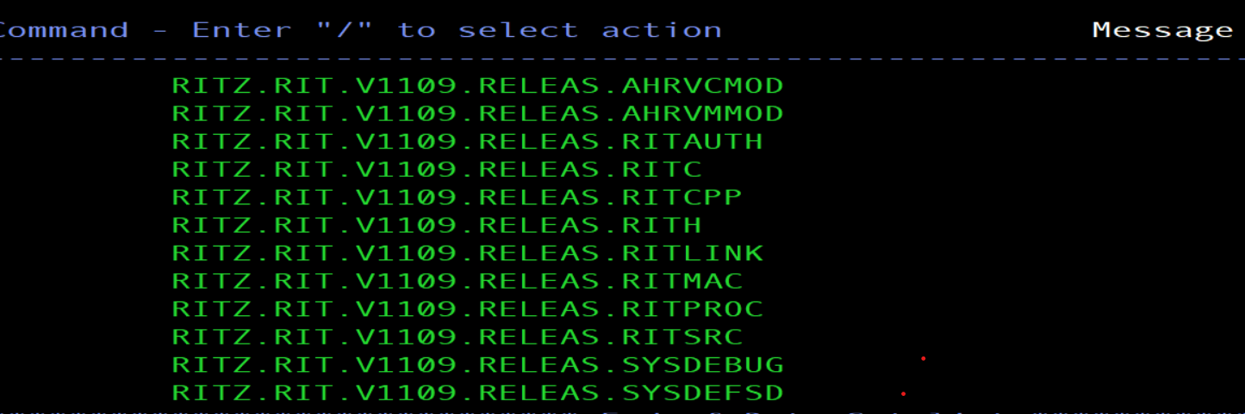

First we ran the below commands to add the programs in LPA and authorize them.
Setprog lpa,add,dsn=MQ.V900.SCSQLINK,mask=*
Setprog lpa,add,dsn=MQ.V900.SCSQSNLE,mask=*
Setprog lpa,add,dsn=RITADM.V1109.RELEAS.RIT.LINK,mask=*
Setprog apf,add,dsn=MQ.V900.SCSQAUTH,vol=#q9000
Setprog apf,add,dsn=MQ.V900.SCSQANLE,vol=#q9000
Setprog apf,add,dsn=MQ.V900.SCSQMVR1,vol=#q9000
SETSSI ADD,SUBNAME=M9F1,INITRTN=CSQ3INI,INITPARM='CSQ3EPX,M9F1,S'

If we do not run Setprog lpa,add,dsn=RITADM.V1109.RELEAS.RIT.LINK,mask=*
we will get the following error:
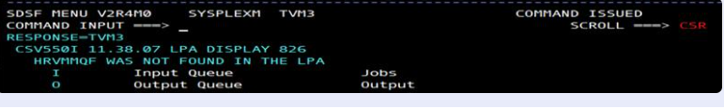

Then, We ran the command to see if the queue is already present.which is already there as shown in screenshot below.
/M9F1 display queue('COM.GREENHAT.COMMAND.QUEUE')

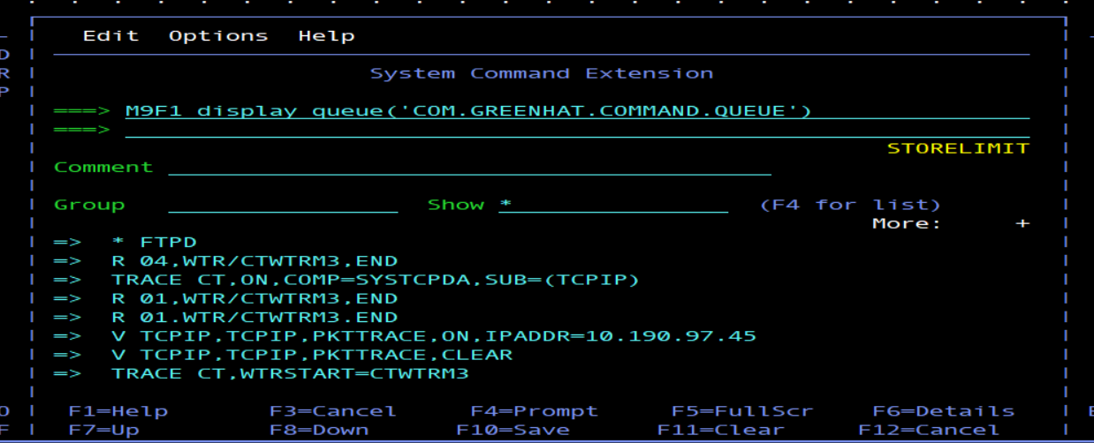
Then,submit the following command to start the queue manager.
/M9F1 START QMGR

Then the channel initiator is started
/M9F1 START CHINIT

We can see the queue manager and Channel initiator are running in Spool
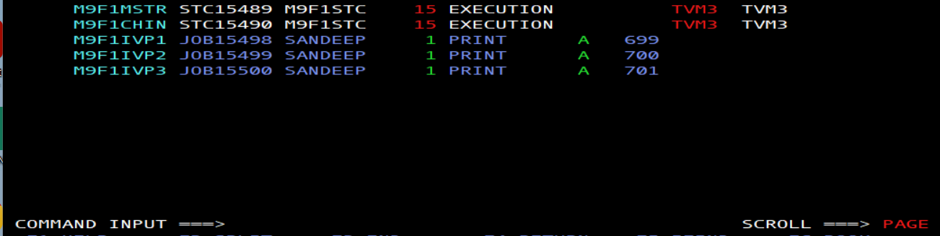

Then ,the RITRUN job in SANDEEP.RIT.PROC is run with the recompiled load ‘RITADM.V1109.RELEAS.RIT.AUTH’ and the MQ agent got started.
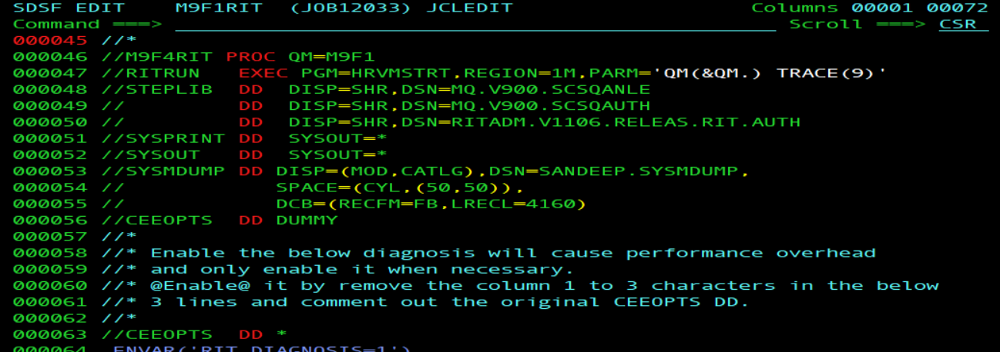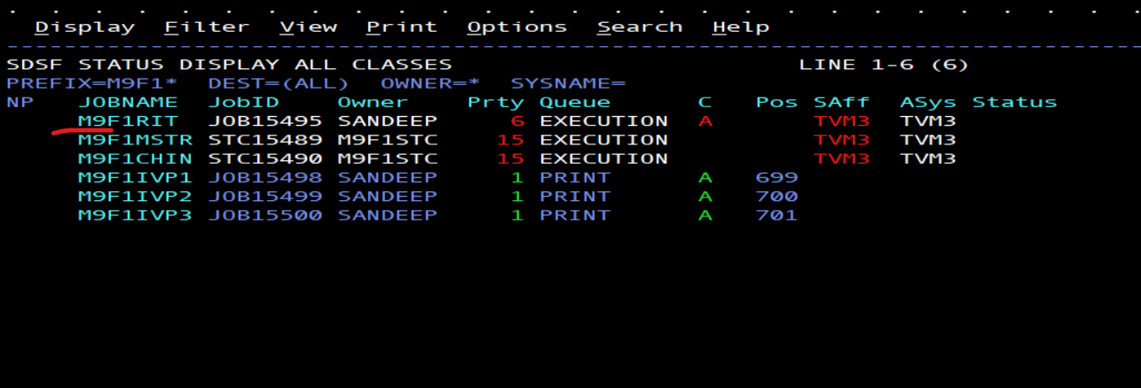
.........Then, we started the testing of the MQ by running the three jobs below…….

- RITIVP1
- RITIVP2
- RITIVP3

RITIVP1 Job:
Creates name lists to direct the agent to duplicate messages put to queue RIT.TEST.INPUT to queue RIT.TEST.RECORD.Creates name lists to direct the agent to divert messages being put to queue RIT.TEST.INPUT2 to queue RIT.TEST.DIVERT. *

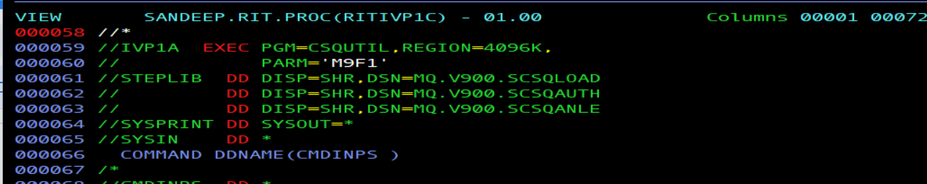

We used the ‘SANDEEP.RIT.AUTH to get the recompiled HRVMPUT code to PUT the messages in RIT.TEST.INPUT and RIT.TEST.RECORD and divert the messages to RIT.TEST.INPUT2 and to queue RIT.TEST.DIVERT.
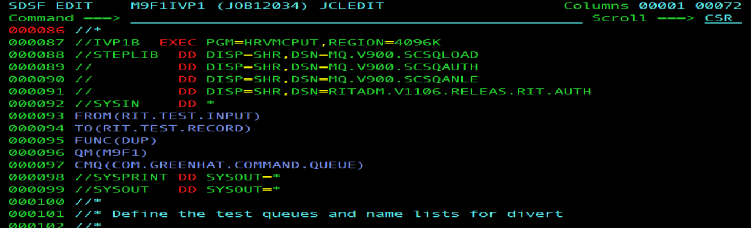

We got the return code 0 for DUP function and DIV function ,means it was successful.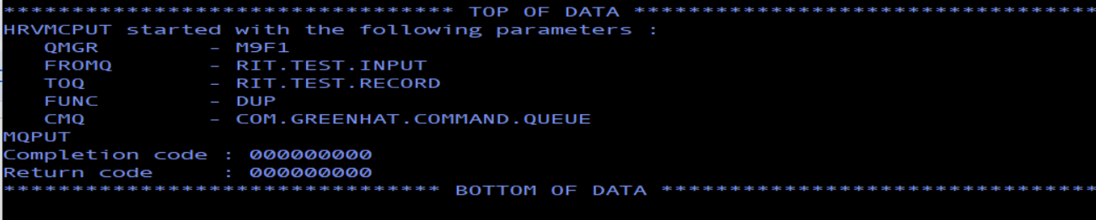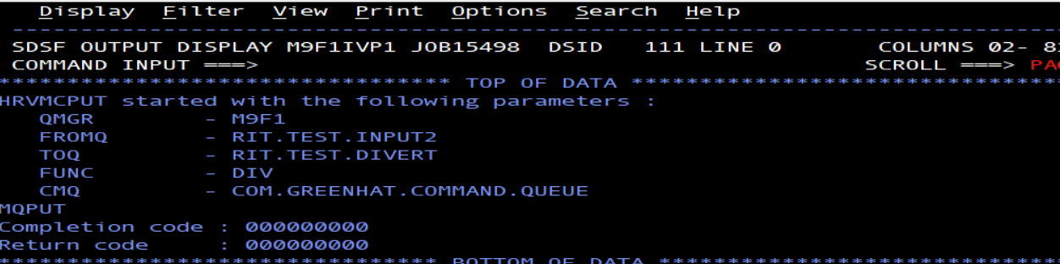

RITIVP2 Job:
Puts a message to RIT.TEST.INPUT, and verifies that the message can be retrieved from both RIT.TEST.INPUT and RIT.TEST.RECORD. Puts a message to RIT.TEST.INPUT2, and verifies that the message can be retrieved from RIT.TEST.DIVERT. *
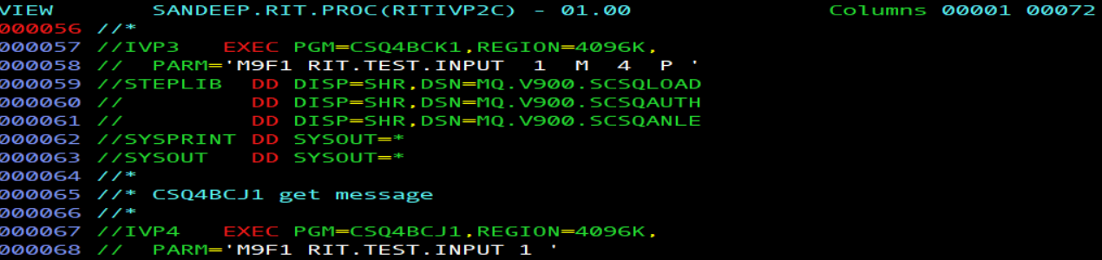

In first step the message is put to QUEUE RIT.TEST.INPUT
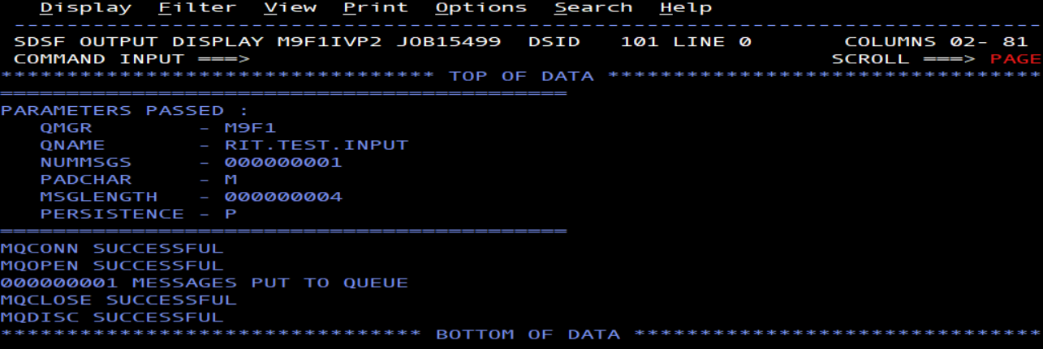
Then,We get the message from the same queue,We were successful in it
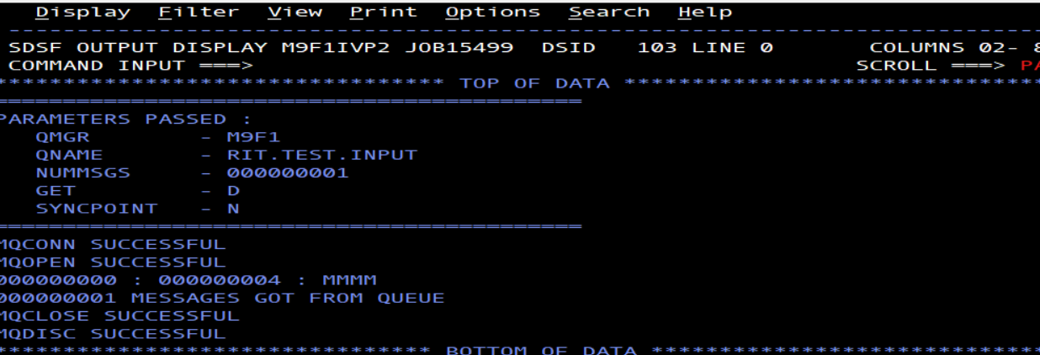

Then,we get the message from the Record queue.
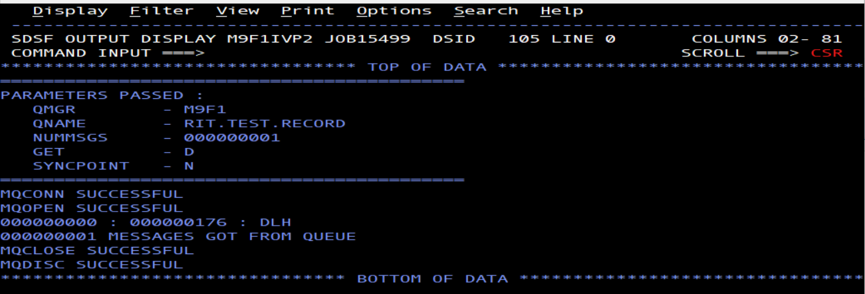

After this We put the message in the ‘RIT.TEST.INPUT2 queue which got successfull 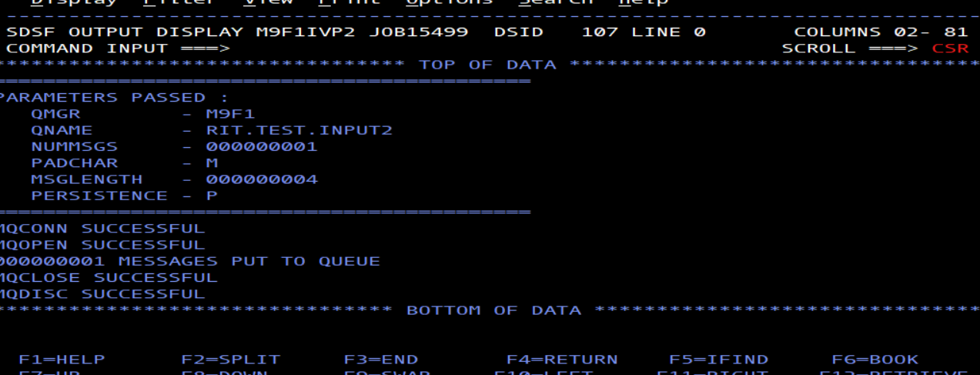

Then we get the msg from RIT.TEST.DIVERT queue with Div function applied and we were successful in it.
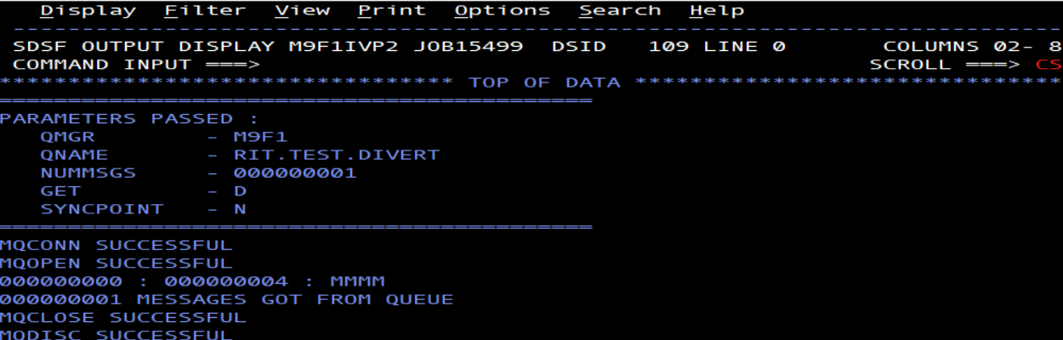

RITIVP3 Job
Deletes the queues that were created in RITIVP1 and removes the queue names from the namelists.
We got the return code 0 and the queues were deleted and removed the names from namelists.  
